**SWINBURNE UNIVERSITY OF TECHNOLOGY**

**COS30045**

**PROJECT STAND-UP 2**

|  |  |  |
| --- | --- | --- |
| **NAME & STUDENTID** | **:** | **Nguyen Gia Binh (104219428)**  **Nguyen Quang Dao (104211864)** |
|  |  |  |
| **CLASS** | **:** | **COS30045** |
| **LECTURER**    **TUTOR** | **:**    **:** | **HOANG XUAN TUNG**  **(**txhoang@swin.edu.au**)**  **HOANG XUAN TUNG**  **(**txhoang@swin.edu.au**)** |

**Hanoi, March 17, 2024**

**TABLE OF CONTENTS**

TABLE OF CONTENTS

**CHAPTER 1: INTRODUCTION**

1.1: Background and Motivation

1.2: Visualization purpose

1.3: Project Schedule and deliverable

**CHAPTER 2: DATA**

2.1: Data source

2.2: Data processing

**CHAPTER 3: REQUIREMENT**

3.1: Must-have Features

3.2: Optional Features

**CHAPTER 4: VISUALIZATION DESIGN**

4.1: Concept

4.2: Manifestation

**CHAPTER 1: INTRODUCTION**

**1.1: Background and motivation**

Migration is a natural and inevitable aspect of human history. In the current globalized world, international migration has become more common. In 2020 alone, there were an estimated 281 million international migrants worldwide, comprising 3.6 percent of the global population (UN DESA, 2020). There are both push factors like conflict, persecution and human rights violations that force people to flee, as well as pull factors like better economic opportunities and living conditions that attract migrants.

Internal displacement due to violence has been a major driver of migration in the Israeli-Palestinian conflict. According to UNRWA, there were over 5.7 million Palestinian refugees as of 2021, including those displaced since 1948 and their descendants (UNRWA, 2021). The situation remains volatile, with frequent outbreaks of hostilities leading to new displacement, particularly in Gaza. A large Palestinian diaspora population also exists outside the region.

Understanding these complex forced migration dynamics is crucial for policies and international relations efforts to resolve the core Israeli-Palestinian conflict and address the refugee crisis humanely based on international law (UNRWA, 2021).

**1.2: Visualization purpose**

In this assignment, a few visualization are made to explore and analyze geographic patterns and underlying events that contribute to complex issues. By synthesizing location-based data, the visualization offers several potential benefits. The Two main events and an additional natural disaster affiliate we will present are the conflict between Isarael and Gaza(Palestine), the invasion of Russian in Ukraine and finally the displacement due to forest fire and other natural disaster of Australia in recent year.

This interactive map and data visualization allows you to delve into what's going on with population displacement in a certain area. First off, the map clearly shows exactly where major events happened that caused displacement over different time periods, so you can pinpoint those locations. Additionally, the viz enables you to further analyze how those displacement-inducing events are dispersed and clustered throughout the region. By combining the geographic map with other visual elements like charts and graphs, you get a comprehensive, multi-faceted picture of the intricate reasons behind mass displacement. Consequently, this tool lets you thoroughly explore the underlying root causes from multiple vantage points and facilitates a deeper understanding of the bigger forces at play in complex situations where sizeable populations are forced to become refugees.

**1.3: Project Schedule and deliverable**

|  |  |
| --- | --- |
| Week | Tasks |
| 6 | 1. Choose the topic 2. Find data about it |
| 7 | 1. Choose the topic 2. Find data about it |
| 8 | 1. Finalize the topic 2. Clean the data |
| 9 | 1. Start making the demo charts 2. Start sketching the front-end to present the visaulization |
| 10 | 1. Choose what kind of visualization you want to use 2. Code the charts out for Isarael vs Gaza(Palestine) 3. Code the charts out for Russia vs Ukraine 4. Finalize on front-end design |
| 11 |  |
| 12 |  |

**CHAPTER 2: DATA**

**2.1: Data source**

We obtain our data from multiple sources, which will be sort out and use in different visualizations.

For the conflict between Isarael and Gaza, I took the data from Humanitarian Data Exchange(HDX). HDX is an open platform that allows verified humanitarian organizations and partners to share crisis data from around the world. The data available on HDX covers a wide range of categories relevant to humanitarian emergencies and crises, such as population statistics, administrative boundaries, displaced populations, damage assessments, health resources, and many more. In a nutshell, HDX provides a one-stop repository for easily accessing and using authoritative humanitarian data to support crisis response, aid delivery, advocacy, research, and data-driven solutions to complex emergencies worldwide. Its open nature democratizes access to crucial information for stakeholders across the humanitarian data ecosystem.

Most of the current data is from this link: <https://data.humdata.org/group/pse>

Geomap of Palestine: <https://cartographyvectors.com/map/1504-palestine-with-regions>

**2.2: Data processing**

The datasets obtained from the aforementioned organizations guarantee both high integrity and timeliness. However, it is essential to conduct data cleaning and restructuring on the original datasets to ensure they meet the necessary level of 'conformity' required for visualization in D3.

**Isarael and Gaza(Palestine) conflict**

The original data have a lot of unnessary data respectively with our intended usage. The initial dataset comprises detailed information concerning recent internal displacement incidents, including the type of event, the number of affected populations, the region of occurrence, and corresponding dates, links, etc. Each entry in this dataset represents an event that caused displacement with precise sequential dates, and coordinate, I decide to delete some of the column that have duplicate and most of the time detail that I have yet to figured out how to visualize it. Furthermore the event name column have duplicate date information in it cells which somehow cause d3 to sometimes has bug. My solution to it is to write a simple python code that would delete the date and the “-” in the data.

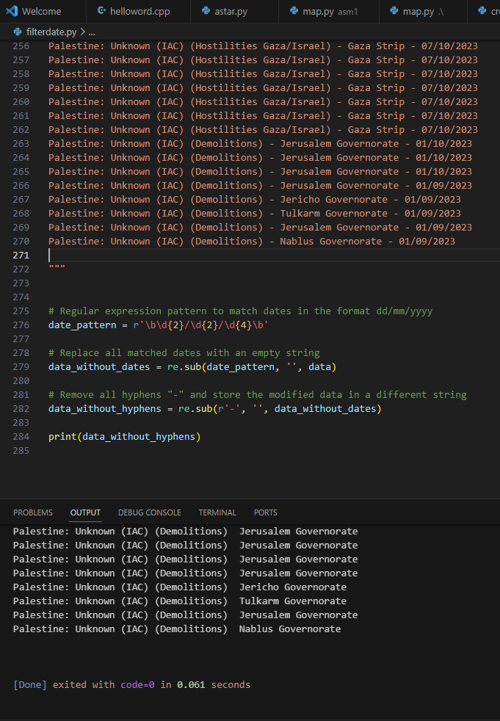

**CHAPTER 3: REQUIREMENT**

**3.1 Must-Have Features**

There are a few features that we consider to be very important to give the reader an easier time understanding of what the chart is for. These features include:

* Interactive visualization:

1. Hover effect: With hover effect, user can see the detail in which a point on the map or a section of a chart represent.
2. Zoom in: This effect allow the user to see the timeline closer especially in line chart or area chart
3. Clickable: Point on the map or sections of the chart may be clickable and would lead to a sub html page with smaller chart or found report representing that point or section

* Additional information:

1. Label: This is a must be to help the reader quickly indentify What the reader is seeing.

* Color: data can be categorize in dozens of type and column, the contrast between color can make some important element to shine through and get to the reader.

**3.2 Optional Features**

1. Tooltip: in the first design, sub pages would be use to give a more detail view on the points or section of the data but if we use tool tip, there would need to be a sub page and therefore maintaining the page integrity would be easier but at the same time tooltip is relatively hard to implement effectively and easily in my experience.
2. Guide: There should be a guide either by a button or render out next to the chart to give the reader an easier time indentify each section.

**CHAPTER 4: VISUALIZATION DESIGN**

**4.1: Concept**

In the early stage, charts and map are coded out simple in order to give an overall design to it and so that later on we can lean our back onto the ready skeleton of the chart.

**Isarael and Gaza(Palestine) conflict**

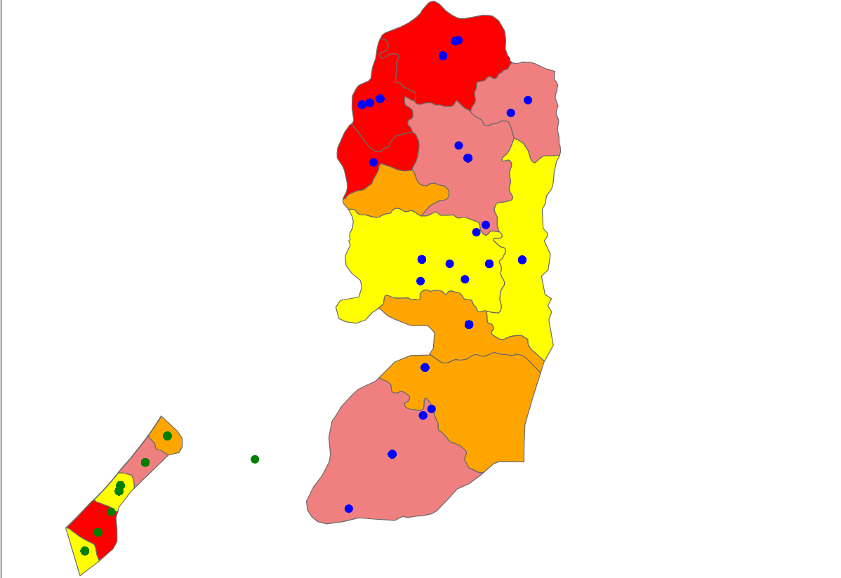

In here green is our focus area in which the main conflict between Isarael and Gaza happen. As of now, the dots are so near each other that it seem only a handful of it happen but in reality it is around 100 dots cluster together since the areas is hit so often. We plan to make a bigger circle with scale color to show the severity of each area and later the hover effect and/or subpage will be added to show more detail information.

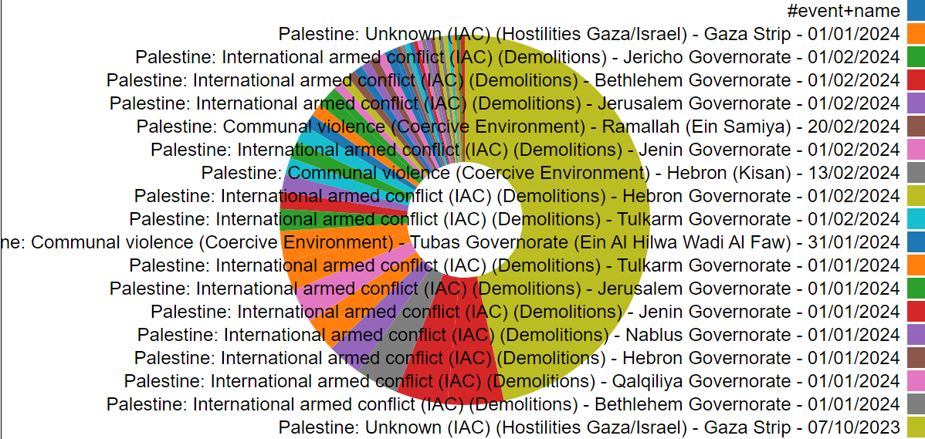

Next is the pie chart to show which event affect the dataset the most, this chart is not yet completed as the code to clean the data for this section is not yet fully working and as a result return the same event but with different date as a slice. The legend for this is as intended just not ready because later on there will be a button to signal the legend to show below the chart or as a hover.

**4.2: Manifestation**

**CHAPTER 5: VALIDATION**

**\*Project stand-up* in progress**

**CHAPTER 6: CONCLUSION**

**REFFERENCE**

International Migrant Stock 2020. (n.d.). https://www.un.org/development/desa/pd/sites/www.un.org.development.desa.pd/files/files/documents/2021/Jan/undesa_pd_2020_international_migrant_stock_documentation.pdf

Canton, H. (2021). United Nations Relief and Works Agency for Palestine Refugees in the Near East—UNRWA. In *The Europa Directory of International Organizations 2021* (pp. 286-289). Routledge.